LOT  hgdh | fgfg  fggf  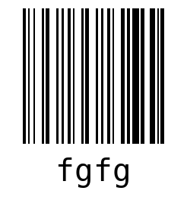  WO fgfg  LOT hgdh  QTY 1

SHEET  1 | fgfg  fggf  WO fgfg  LOT hgdh

